1. **Steps for Creating VPC and peering onnections :-**

**a. First go aws console and search for vpc interface in search bar**

**b. After entering go to left side page in that select your VPCs**

**c. Start creating VPC as shown below images..**

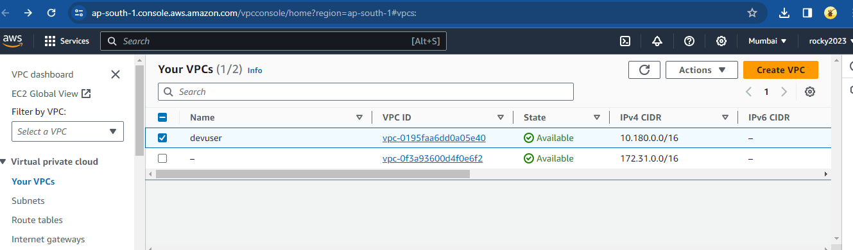

1. **Step for create peering connections :-**
2. **Select Create tab for creating ..**

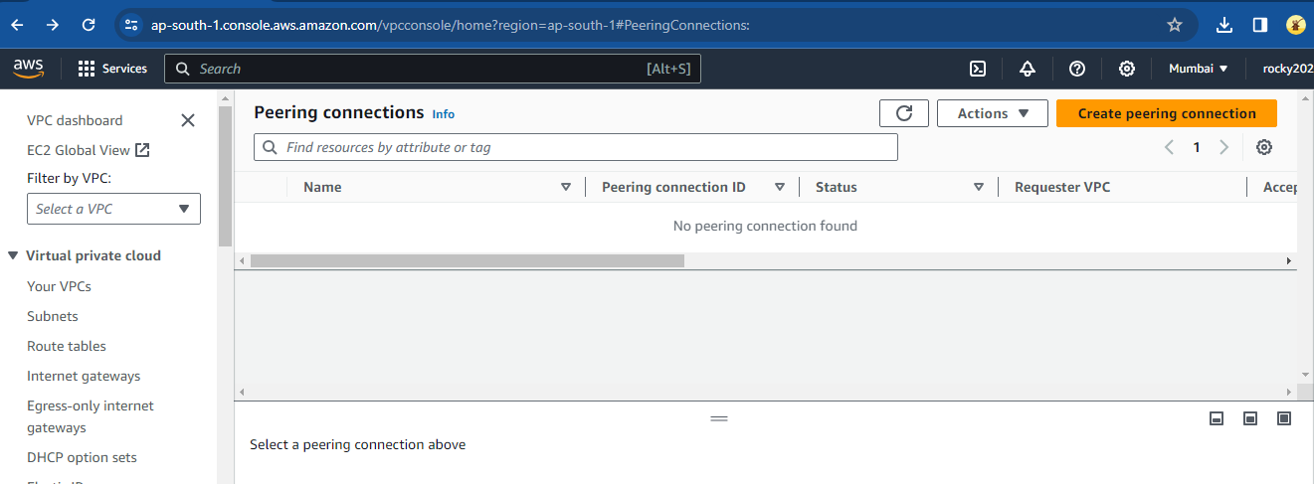

1. **Adding credentials for crate peering connection as shown in below image…**  
   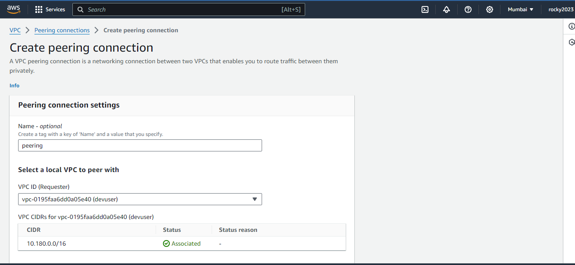
2. **Continue as fallows from above image to create peering connections :-**

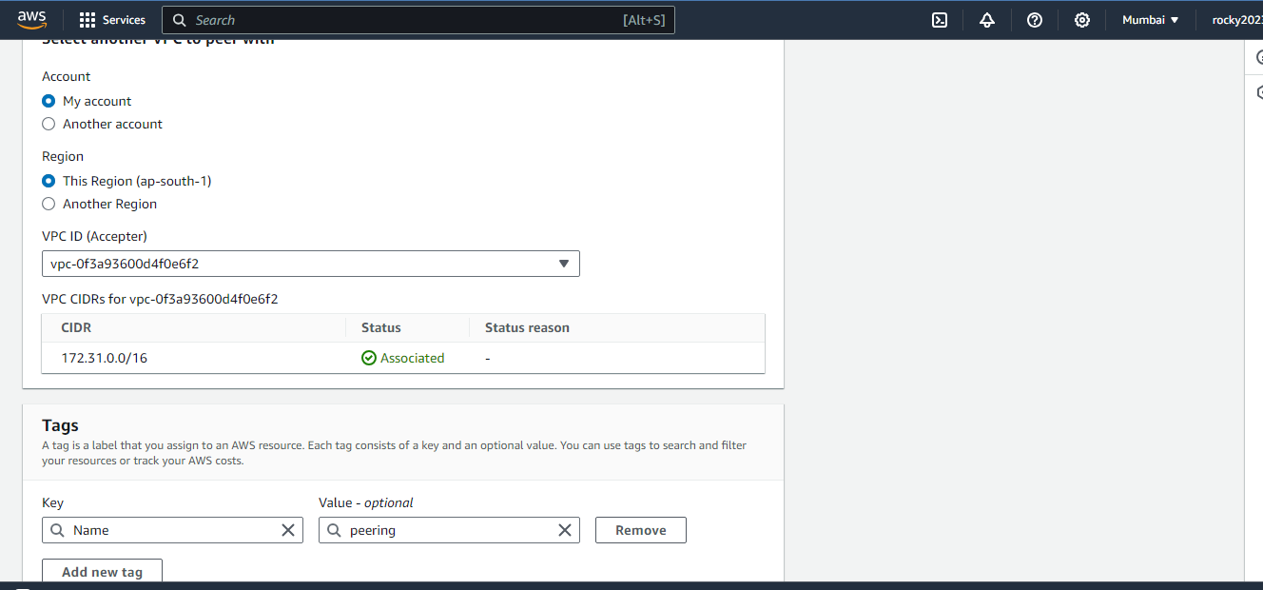

1. **Below image shown clearly that VPC peering connection requested..:-**

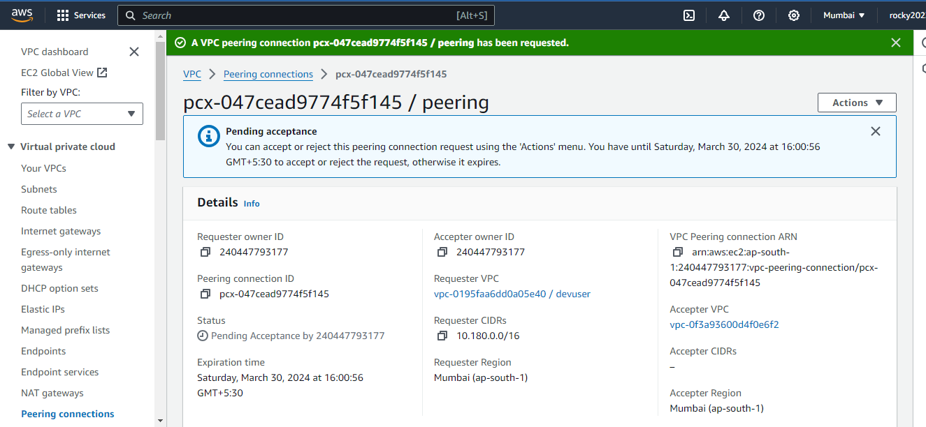

1. **Below image as fallows from above images to peering :-**

